tempo2 general2 — Complete Variable Reference
This document is compiled directly from the tempo2 general2 plugin source code. It lists the variables and control directives that can be used inside the general2 format string (via -s or -file). This reference is derived directly from the tempo2 general2 plugin source code. It lists commonly used variables and control directives for scripting, PTA analyses, MCMC, and automated pipelines.

### Dejiang Yin /2026/01/21
##
- general usage

# the following * from: https://github.com/OZGrav/meerpipe/blob/main/tempo2_wrapper.sh

echo "Generating residuals"
echo "----------------------------------"
# general2 is a tempo2 pluggin: https://github.com/mattpitkin/tempo2/blob/master/plugin/general2_plug.C
# It allows the output of the residuals to be formatted as:
# bat: barycentric arrival time (MJD)
# post: postfit residual (s)
# err: postfit residual error (ns)
# freq: frequency (MHz)
# post_phase: postfit in phase
# flags: flags from the toa files
tempo2 -nofit -output general2 -s "{bat} {post} {err} {freq} {post_phase} {flags}\n" -outfile ${archive}.residual -set START 40000 -set FINISH 99999 -nobs 1000000 -npsr 1 ${select_command} -f ${ephemeris} ${archive%%.tim}.tim && returncode=$? || returncode=$?
##
Barycentric arrival time (MJD) | Post-fit timing residual (seconds) | TOA uncertainty (seconds)
tempo2 -f example1.par example1.tim -output general2 -s "{bat} {post} {err}\n" -outfile example1.residual

1. 基础版（提取轨道相位 + 拟合后残差）
tempo2 -nofit -output general2 -s "{binphase} {post} {err}\n" -outfile orbital_phase_residuals.txt -f 你的星历文件.par 你的TOA文件.tim

2. 进阶版（含相位 + 前 / 后残差 + 频率，适配多维度绘图）
tempo2 -nofit -output general2 -s "{binphase} {post} {err}\n" -outfile orbital_phase_residuals.txt -f 你的星历文件.par 你的TOA文件.tim
但是这种方式输出的似乎点不对<><>????待确定....
##没问题！tempo2 -nofit -output general2 -s "{bat} {post} {err}\n" -outfile M2A_demo.txt -f M2A_demo.par M2A.tim
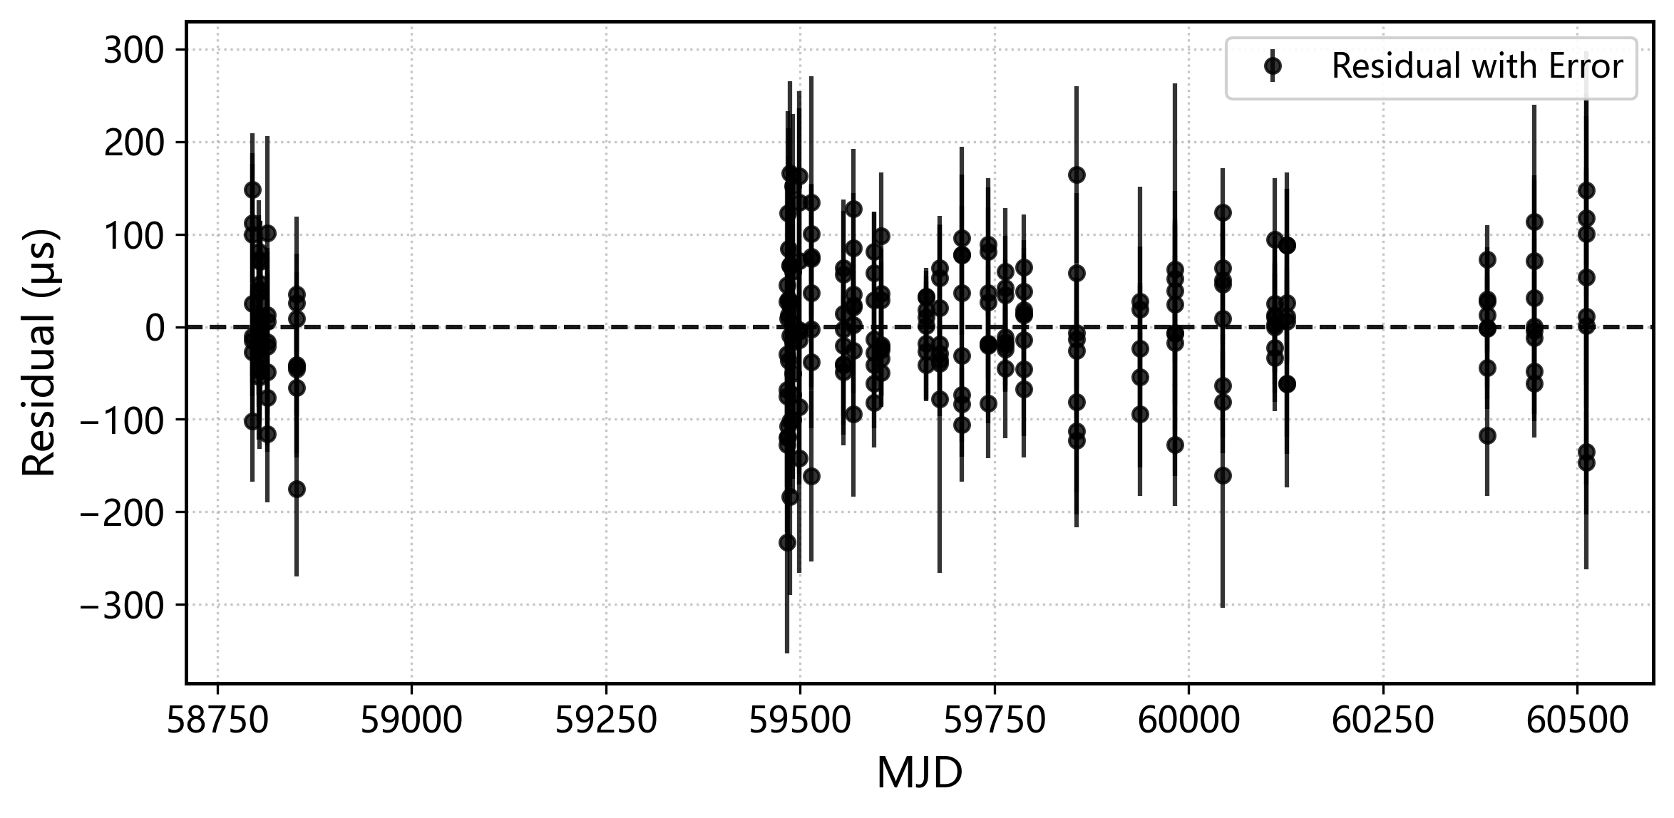
$#####
tempo2 -gr plk -f M2A.par M2A.tim -publish -nohead
tempo2 -gr plk -f M2A.par M2A.tim -publish
进入之后点击h，E, g, 输入/PS, /CPS可以生成ps图片，
ctrl-p Toggle plotting versus pulse phase
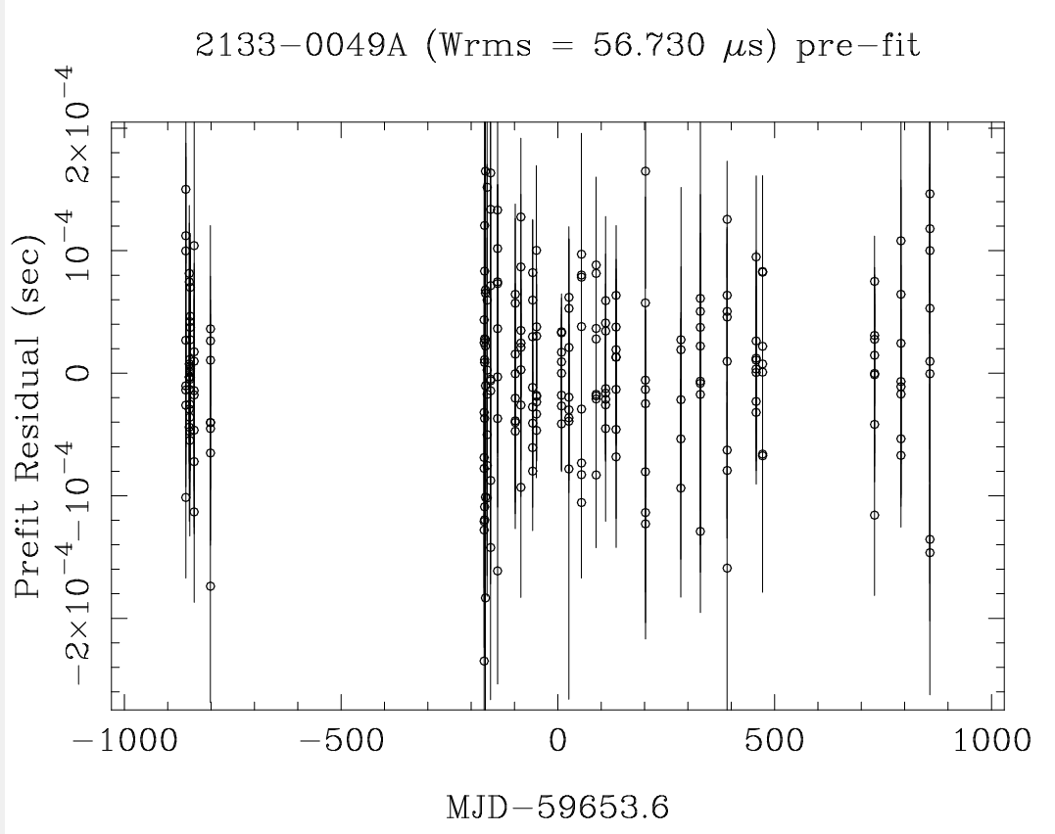
- more details for tempo2 general2 plugi

Time / TOA Variables
Variable / Directive | Description
{sat} | Site arrival time (MJD)
{bat} | Barycentric arrival time (MJD)
{bbat} | Binary barycentric arrival time
{pet} | Pulsar emission time
{x} | BAT − PEPOCH
{mjd} | Original TOA MJD
{binphase} | binary phase

Residuals
Variable / Directive | Description
{pre} | Pre-fit timing residual (seconds)
{post} | Post-fit timing residual (seconds)
{pre_phase} | Pre-fit residual (phase)
{post_phase} | Post-fit residual (phase)
{posttn} | Post-fit residual with temponest noise removed

TOA Uncertainties
Variable / Directive | Description
{err} | TOA uncertainty (seconds)
{avgerr} | Averaged TOA uncertainty

Frequency Related
Variable / Directive | Description
{freq} | Observing frequency
{freqSSB} | Frequency at the Solar System Barycentre
{freqCOE} | Frequency at the centre of Earth

Observatory / Backend
Variable / Directive | Description
{obs} | Observatory code
{tel} | Telescope name
{backend} | Backend name
{rcvr} | Receiver name

Geometry / Position
Variable / Directive | Description
{earth_ssb} | Distance Earth → SSB
{earth_ssb1} | Earth → SSB X component
{earth_ssb2} | Earth → SSB Y component
{earth_ssb3} | Earth → SSB Z component
{sun_ssb1} | Sun → SSB X component
{sun_ssb2} | Sun → SSB Y component
{sun_ssb3} | Sun → SSB Z component
{posPulsar} | Pulsar position vector
{velPulsar} | Pulsar velocity vector
{telSSB} | Telescope position relative to SSB

Propagation / Delay Terms
Variable / Directive | Description
{roemer} | Roemer delay
{shapiro} | Solar Shapiro delay
{ism} | Interstellar medium delay
{ipm} | Interplanetary medium delay
{tropo} | Tropospheric delay
{clock} | Clock correction delay

Binary / Orbital
Variable / Directive | Description
{orbphase} | Binary orbital phase
{trueanom} | True anomaly
{eccentricity} | Binary eccentricity

DM / Noise (temponest)
Variable / Directive | Description
{tndm} | Maximum-likelihood DM signal
{tndmerr} | DM uncertainty from temponest
{tnrn} | Red noise contribution
{tnchrom} | Chromatic noise contribution

Derivatives (Advanced)
Variable / Directive | Description
{d_F0} | Partial derivative of residual w.r.t. F0
{d_F1} | Partial derivative of residual w.r.t. F1
{d_DM} | Partial derivative of residual w.r.t. DM
{d_PB} | Partial derivative of residual w.r.t. binary period PB
{d_A1} | Partial derivative of residual w.r.t. projected semi-major axis A1

Format / Control Directives
Variable / Directive | Description
{FORMAT %.Ne} | Set floating-point output format
{ERRMULT x} | Multiply TOA uncertainties by x
{TAB n} | Insert tab / alignment spacing
{NULL string} | String for undefined values
{RAD} | Output angles in radians
{NORAD} | Output angles in degrees
{SUB1} | Subtract first residual from all residuals

